DRL 2

- Display the average, lowest, highest and difference in lowest and highest salaries for each department number.

SELECT DEPTNO, ROUND(AVG(SAL),2) "AVERAGE", MIN(SAL) "LOWEST", MAX(SAL) "HIGHEST", MAX(SAL) - MIN(SAL) "DIFFERENCE OF HIGHEST AND LOWEST"
FROM EMP
GROUP BY DEPTNO
ORDER BY DEPTNO;

- Display the number of employees within each job.

SELECT JOB, COUNT(JOB) "NUMBER OF EMPLOYEES"
FROM EMP
GROUP BY JOB
ORDER BY JOB;

- Display only those jobs where the minimum salary is greater than or equal to 3000.

SELECT JOB
FROM EMP
GROUP BY JOB
HAVING MIN(SAL)>=3000;

- Calculate and display only the average salaries paid to all those employees where the employee name starts with A and name starts with S.

SELECT ROUND(AVG(SAL),2) "AVERAGE SALARY"
FROM EMP
WHERE
ENAME LIKE 'A%'
OR
ENAME LIKE 'S%';

- Product exactly same output as shown below:

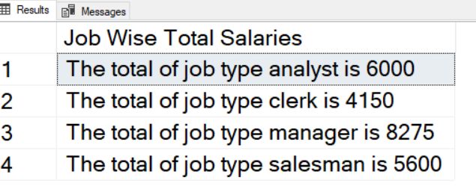

SELECT 'The total of job type ' || JOB || ' is ' || SUM(SAL) "JOB WISE TOTAL SALARIES"
FROM EMP
GROUP BY JOB
ORDER BY JOB;

- Product exactly same output as shown below:

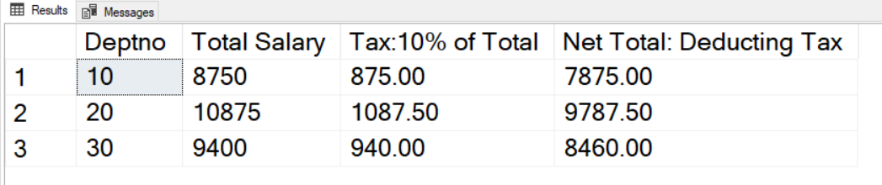

SELECT DEPTNO, SUM(SAL) "TOTAL SALARY", ROUND(0.1*SUM(SAL),2) "TAX : 10% OF TOTAL", ROUND(SUM(SAL) - 0.1*SUM(SAL), 2) "NET TOTAL : DEDUCTING TAX"
FROM EMP
GROUP BY DEPTNO
ORDER BY DEPTNO;

